**Module 2 Challenge Written Analysis**

**January 16, 2022**

The purpose of this stock analysis is to provide automated analysis of stocks in a timely manner. The analysis is color coded to understand change in stock prices very easily. For example, below is 2017 and 208 all stocks analysis table. Steve can switch between years easily using the buttons next to the table. Based on the analysis most stocks are not profitable during year 2018 except ENPH and RUN.

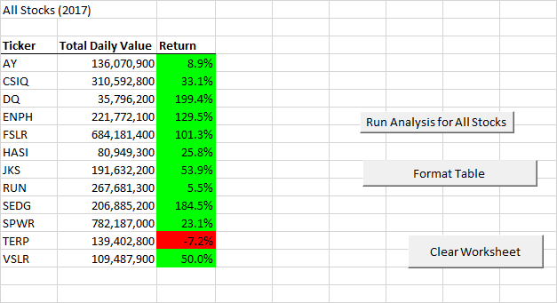

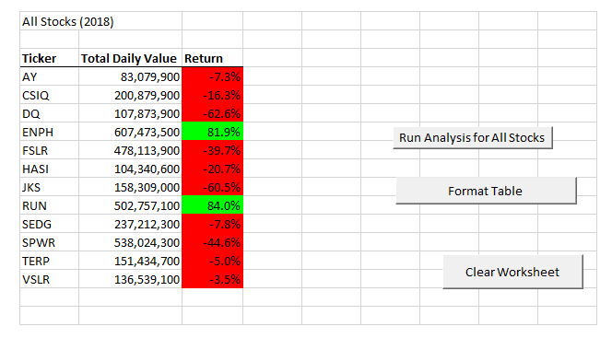

As see above, VBA is a powerful tool to analyze large amount of data very easily. By refactoring the initial single stock analysis, we are able to loop through all stock data and generate analysis for all stocks within a fraction of second. Refactoring has its own pros and cons.

**Pros and cons of refactoring:**

**“Advantages of Code Refactoring:**

**Extensible Code:**Code Refactoring makes the code more extensible for adding many other functions to it. It also helps in increasing the flexibility of the code and by this the capability of code increases.

**Maintainability:**After refactoring, the code is fresher, easier to understand or read, less complex and easier to maintain.

**Disadvantages of Code Refactoring:**

**Time Consuming:**You may have no idea how much time it may take to complete the process. It may also land you into a situation where you have no idea where to go.

**Chance of Mistakes:**In case if it went wrong, you will have to waste much more time in solving the problem and there are probable chances that it may go wrong due to complexity of the code.

Code Refactoring is a wise method of extending the code and making it more capable and in the same way it has some disadvantages. One need to make up his/her mind whether it is necessary to go for refactoring or not.” (https://anarsolutions.com/code-refactoring-concept-analysis)